Continuous Quality Improvement Plan Worksheet
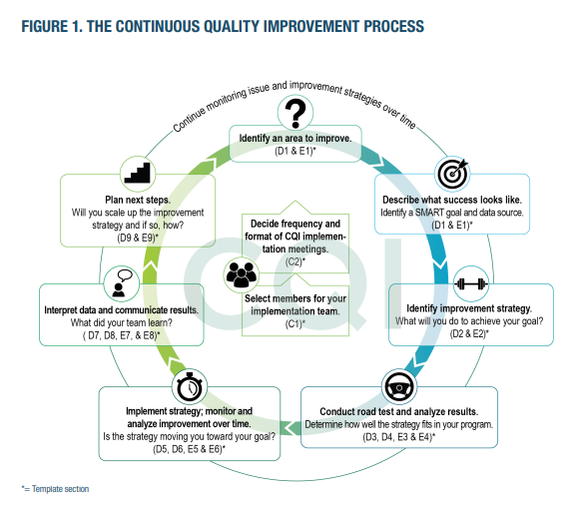
Instructions
This worksheet is a companion resource to the CQI plan template found on the HMRF Grantee Resources site (https://www.hmrfgrantresources.info/continuous-quality-improvement). It is an optional resource to help organize information about your grant’s CQI cycles and review progress with your Family Assistance Program Specialist (FPS) in the Office of Family Assistance (OFA). OFA recommends reviewing CQI plans with your FPS at the beginning and end of each CQI cycle.
This worksheet is structured based on the steps in the CQI process (Figure 1, outer circle) and the corresponding sections of the CQI plan template. Overwrite the instructions in each text box with your responses. For ease of use, use tab to move between fields (or “shift+tab” to reverse). Hold “Ctrl” and click on the links provided with the “Need help?” icons in the worksheet to access resources relevant to that step in the CQI cycle.

Grantee and CQI plan information
Grantee name Enter grantee name.
Start date of CQI cycle Enter start date.

CQI Process

Step 1. Identify an area to improve
What is the specific problem or issue you are trying to solve? Enter the specific problem or issue.
Need help drafting your problem statement? This worksheet walks through how to draft a strong problem statement. Click for additional resources.
Document your insights: What insights or additional issues did your team identify while investigating the problem? For example, what root causes did your team identify? What should you consider for future CQI cycles?
Enter your insights.

Step 2. Describe what success looks like
What is the SMART goal that would show an improvement on this issue? Enter the SMART goal.
What data source will you use to measure progress towards that goal? Enter the data source.
Need help developing a SMART goal? See the tip sheet on SMART goals for guidance on how to make a strong SMART goal, and for help with determining your measurement strategy.
Document your insights: What insights or additional issues did your team identify when establishing your SMART goal? What process did you use to inform the goal?
Enter your insights.

Step 3. Identify an improvement strategy
Describe your strategy. Enter your strategy.
Describe your rationale for the strategy. Why might this strategy lead to improvements? Enter the rationale.
Need help identifying a strategy? The strategy development tip sheet describes how to generate ideas. Click for more resources on identifying strategies.
Document your insights: Use this space for important notes related to strategy development. For example, did your team develop other promising strategies (in addition to your priority strategy) that you might test later?
Enter your insights.

4. Conduct a road test

Create a road test plan and implement it
What are your learning questions for the road test? Enter your learning questions.
When and how will you implement the strategy? Consider staff responsible, training/tools needed, and key processes. Enter implementation details.
What is your timeline for the road test? When will you start, collect feedback, and complete the road test? Enter the timeline for the road test.
Staff feedback through:  Questionnaire  Focus group  Interview  nFORM  HCD activity  Other (please specify) Enter other staff feedback collection method. | Client feedback through:  Questionnaire  Focus group  Interview  nFORM  HCD activity  Other (please specify) Enter other client feedback collection method. | Others’ feedback:  Please specify who and how  Enter other feedback collection method.
How will you collect feedback during the road test? (Check all that apply)

Need help with planning a road test? See the tip sheet on developing learning questions to guide a road test.

Once you’re done, analyze road test results
Analyze the road test results: What worked well, what should change?
Enter the road test results.
Decide whether to revise, maintain, or abandon the strategy.
Revise Restart Step 4 and revise your plans for road testing the strategy.
Maintain Continue to Step 5 to implement the strategy and monitor over time.
Abandon Return to Step 3 to identify a new strategy to address the problem.
Need help analyzing road test results and deciding next steps? See the tip sheet for reflecting on your road test and the decision tree tip sheet for suggestions. Click for more resources on planning, conducting, and analyzing results of a road test.

Document your insights: Use this space to note insights that emerged from the road test. Note any unanticipated or unrelated challenges that you should return to later.
Enter your insights.

5. Implement the strategy and monitor and analyze improvement
What is your implementation plan? Enter your implementation plan.
How frequently will you monitor your strategy, and until what point? (e.g., “monthly for 3 months”) Enter the frequency of monitoring.
Who is responsible for monitoring progress? Enter role or name.
Did you make progress toward your SMART goal? Enter results.
Need additional resources? Click for resources on monitoring progress.
Document your insights: Did this CQI effort change your ongoing program monitoring processes? For example, if you were not already monitoring your SMART goal, will you incorporate it into your routine monitoring process?
Enter your insights.

6. Interpret data and communicate results
With your CQI team, review your data and decide on key summary findings for each learning question you identified in Step 4. Also consider progress made on your SMART goal. Begin each statement with the phrase: We learned that…
- We learned that: Enter first key takeaway.
- We learned that: Enter second key takeaway.
- We learned that: Enter third key takeaway.
Describe how the CQI team will communicate its efforts to others, including the role of CQI, obtaining feedback on issues to address, informing staff of changes being tested, and results.
Enter how the CQI team will communicate its efforts to others.
Need help with your communication plan? The tip sheet on scaling and sustaining improvement efforts describes common barriers to buy-in and how to address them. Click for other resources on interpreting data and communicating results.

7. Plan next steps
Consider next steps based on your findings in Step 6. If you do not see progress on your SMART goal, will you revise or abandon your strategy? If your strategy has not been implemented program-wide, will you scale-up the strategy, and if so, how and when? If you are not ready to scale-up, what next steps will your program take towards improvement?
Enter next steps.
Need help deciding? See the decision tree tip sheet, or click for additional resources.
Document your insights: Use this space to note key insights related to your strategy and your decision whether to continue it, revise it, expand it, or abandon it.
Enter your insights.
If you have questions about using this worksheet or any aspect of conducting CQI, please contact the BUILD CQI Help Desk at hmrfcqi@mathematica-mpr.com.
This tip sheet was prepared by Allon Kalisher, Annie Buonaspina, and Scott Richman of Mathematica, Washington, DC, (2022) under contract with the Office of Planning, Research and Evaluation, Administration for Children and Families, U.S. Department of Health and Human Services (HHSP233201500035I/75P00120F37054). OPRE Project Officers: Katie Pahigiannis, Pooja Gupta Curtin, Harmanpreet Bhatti, and Rebecca Hjelm. Mathematica Project Director: Grace Roemer.

An “HCD activity” is a human-centered design activity. For further information about HCD, see A Review of Human-Centered Design in Human Services at https://www.acf.hhs.gov/opre/report/review-human-centered-design-human-services.

