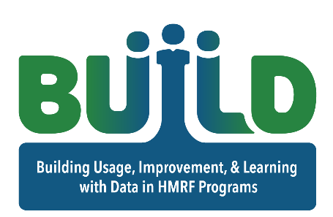  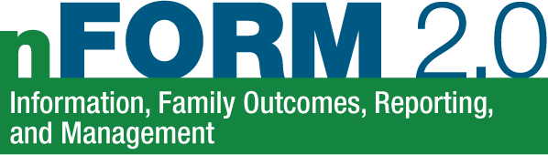  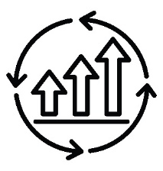 |  |  | HMRF Data-Driven Questions Worksheet
Everyone has a role in data-driven program improvement. You can use data from nFORM 2.0 and other sources to monitor progress towards your own and your program’s goals. Use this worksheet to record questions you have about your HMRF grant work. Then, discuss your questions with your HMRF data manager who can help identify and obtain the information needed to answer your questions. Review the information with your data manager to formulate answers to your questions and identify next steps. Next steps can be both immediate (how can I address what I found?) and ongoing (how can I review my work and address issues on a regular basis?). If you and your data manager need assistance identifying nFORM 2.0 information sources, contact the nFORM 2.0 help desk by either submitting a ticket through the help tab of nFORM or emailing us at nform2helpdesk@mathematica-mpr.com. We are happy to help!
Question | Information source(s) | Answer(s) |  | Next Steps
Example (case manager): How did I do in the prior two-week period in meeting with each client at least once? | Example: The nFORM 2.0 individual service contact operational report includes data on the number of substantive and reminder-only contacts provided to clients | Example: The detailed page of the report shows that I have provided at least one substantive individual service contact to 9 out of my 10 assigned clients over the past two weeks. |  | Example:  - Follow up with the client who I did not meet with in the past two weeks  - Ask my grant’s data manager to generate the individual service contacts report every two weeks to make sure I am providing and recording all service contacts according to my program’s case management approach.
Example (facilitator): How can I improve engagement with clients during workshop sessions? | Example: Workshop session observations can identify what is working well to engage clients and where there are challenges. Workshop exit slips or feedback forms provide client perspectives on how they felt about a session. | Example: The program manager observed that clients were more engaged during group discussions and activities, but were less interested during lecture portions of the session. Of the 12 feedback forms completed, 6 of the clients noted that they did not feel the session materials were helpful. |  | Example:  - Work with other staff to update workshop materials that are more useful for clients  - Debrief with my grant’s data manager each week to discuss classroom observations and the responses provided by clients on the workshop feedback form
Question | Information source(s) | Answer(s) |  | Next Steps

This tip sheet was prepared by Hannah McInerney and Annie Buonaspina of Mathematica, Washington, DC, (2023) under contract with the Office of Planning, Research and Evaluation, Administration for Children and Families, U.S. Department of Health and Human Services (HHSP233201500035I/75P00120F37054). OPRE Project Officers: Katie Pahigiannis, Pooja Gupta Curtin, Harmanpreet Bhatti, and Rebecca Hjelm. Mathematica Project Director: Grace Roemer.

