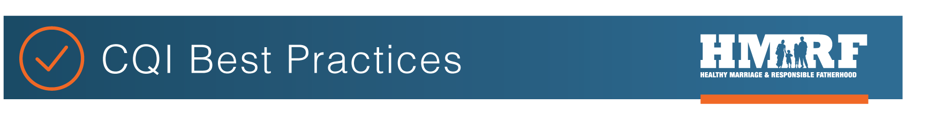
OPRE report #2022-191
IMPLEMENTATION TEAM AGREEMENT WORKSHEET

This worksheet provides a template that implementation teams can use to define core team agreements. Questions are provided in each section to guide the development of a team agreement with a focus on CQI.

Implementation teams are responsible for actively supporting implementation of the program. Team members should have detailed knowledge of the program. An implementation team is not an advisory group, but rather a team that is actively and regularly involved in program implementation.

COMPONENT | GUIDING QUESTIONS | RESPONSES AND NOTES
Vision | - What is the overarching vision for the team? How does the vision emphasize CQI?  - Does this align with the organization’s vision?
Goals and Objectives | - What are the main purposes of the team related to CQI?  - What are the team’s goals for using data to inform decision-making and improvement?
Roles, Responsibilities  and Scope | - Who participates and in what roles?  - What are the team’s responsibilities?  - How do team members share accountability for CQI? (For example, who will be responsible for gathering data and information?)  - How does the IT communicate or work with other groups (like an evaluation team, or outside partner/group)?”
Communication Protocols | - How does this team communicate internally?  - How do team members gather and share information outside the team and feedback related to CQI efforts?  - When improvement decisions are made, how are they communicated?  - Who communicates team activities and decisions and how often?
Resources available to the group or project | - What resources are available to support the implementation team’s work? Specifically, what resources are available to support CQI?  - What resources are important to document in this agreement?
Authority and Influence and Decision-Making Process | - What authority does the team have in making CQI improvement decisions?  - How does the team make decisions?  - What are the limits of the team’s authority?
Deliverables | - What are expected deliverables (and anticipated timing) of the team and its members?
After answering the questions above, you can then make this into a standalone implementation team agreement document, or keep it in the table format above. Once completed, have each team member sign it and pick a date in the future to revisit this agreement and make any changes needed at that time. (Note: add signatures as needed.)

Team Member #1 Signature: __________________________________________________________________________________

Team Member #2 Signature: __________________________________________________________________________________

Team Member #3 Signature: __________________________________________________________________________________

Team Member #4 Signature: __________________________________________________________________________________

Team Member #5 Signature: __________________________________________________________________________________

Date initially signed _______________________________

Date to revisit ____________________________________

This resource was written by Sarah Avellar (Mathematica) and Liz Pollock (Office of Planning, Research, and Evaluation (OPRE)) based on materials from the University of North Carolina’s Frank Porter Graham Child Development Institute - National Implementation Research Network in collaboration with the Administration for Children and Families’ Office of Family Assistance (OFA) and OPRE (contract #HHSP2332009564WC/HHSP23337050T). OPRE Project Officers: Katie Pahigiannis and Pooja Gupta Curtin. Mathematica Project Director: Sarah Avellar.
Suggested citation: Avellar, S. and L. Pollock (2020). Implementation Team Agreement Worksheet (OPRE Report 2022-191). Washington, DC: Office of Planning, Research and Evaluation, Administration for Children and Families, U.S. Department of Health and Human Services.

